**General Test Method for Lead and Phthalate Screening**

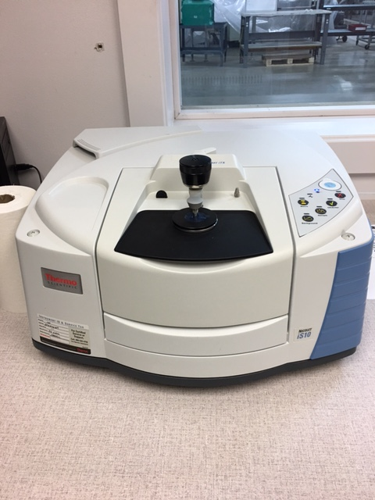 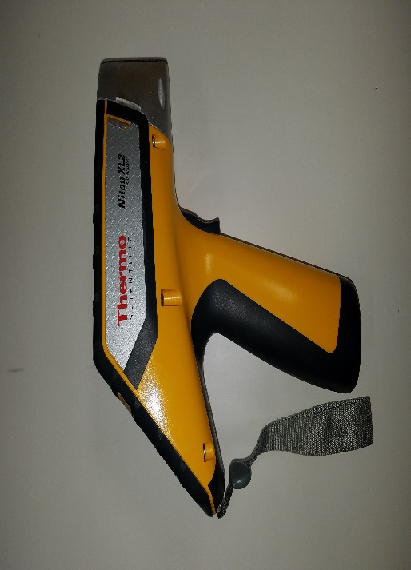

CONTENTS

1 Equipment 3

1.1 Lead Screening Specific Equipment 3

1.2 Phthalate Screening Specific Equipment 3

2 Software 3

2.1 NDTr 3

2.2 OMNIC Software 3

3 Setup 3

3.1 XRF Setup: 3

3.2 FTIR Setup: 3

4 General Test Procedure 6

4.1 Lead Screening in Metals 6

4.2 Lead Screening in Plastics 7

4.3 Toxics in Packaging Screening 7

4.4 Phthalate Screening 8

5 Data Format and Reporting 13

5.1 Section 4.4 13

1. Equipment

The Following Equipment is required for this testing:

* 1. Lead Screening Specific Equipment
     1. Thermo-Fisher Scientific Niton X-Ray Fluorescence [XRF] Gun
        1. This is used to identify lead in metals, plastics, and packaging.
     2. Lead Enclosure
        1. This is used to protect the operator from x-ray radiation.
  2. Phthalate Screening Specific Equipment
     1. Thermo-Fisher Scientific Nicolet iS10 Fourier Transform Infrared [FTIR] Spectroscope
        1. This is used to identify plastics and if phthalates are present in plastics. The method used to identify phthalates is the Attenuated Total Reflectance [ATR] method.
     2. Alcohol Wipes
        1. Used to clean the diamond and plate of the FTIR machine.
     3. Cutters
        1. Used to cut samples for testing.
     4. Attenuated Total Reflectance [ATR] Attachment
        1. Used to test samples without melting the plastic into thin films.

1. Software
   1. NDTr

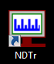

* 1. OMNIC Software

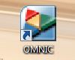

1. Setup
   1. XRF Setup:
      1. Attach the XRF Gun to the lead enclosure and connect the wires from the enclosure.
      2. Power the XRF Gun on and open the NDTr software.
      3. Log into the software.
   2. FTIR Setup:
      1. FTIR Spectroscope
         1. Unscrew the clamp holding the cover on the plate and remove the cover *(Fig 1)*.

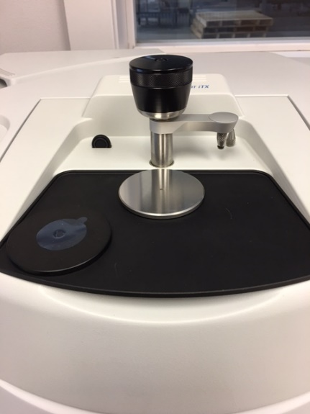

*Figure 1: Cover Removed*

* + - 1. The plate should be clean from the previous session.
    1. Sample Preparation
       1. The samples should be large enough to cover the entire diamond *(Fig 2)*.

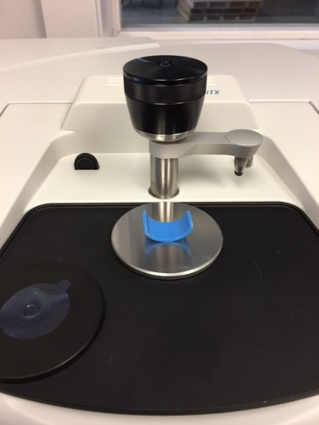

*Figure 2: Sample covering the viewing diamond.*

* + - 1. The sample should be clean and free from debris.
    1. Background Samples
       1. Open the OMNIC Software.
       2. You will be prompted with a pop-up. Make sure to select “00 Material Screening” as your program. This should be the default program *(Fig 3)*.

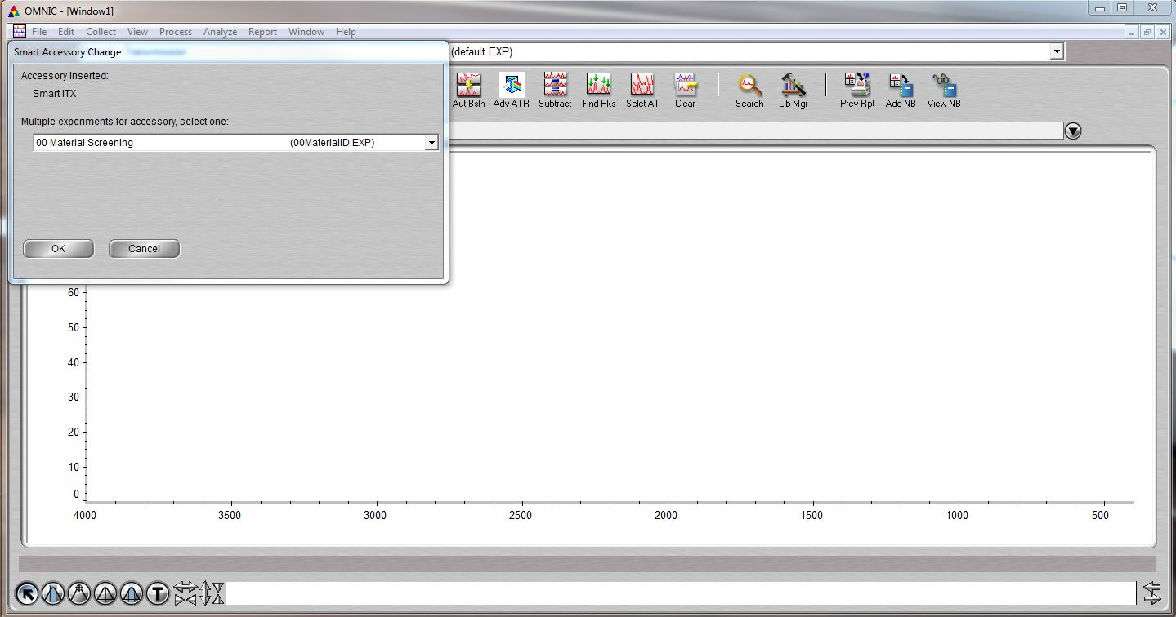

*Figure 3: Select “00 Material Screening”*

* + - 1. Before taking the Background Sample, move the clamp out of the way, remove the cover, and remove any sample from the diamond *(Fig 4)*.

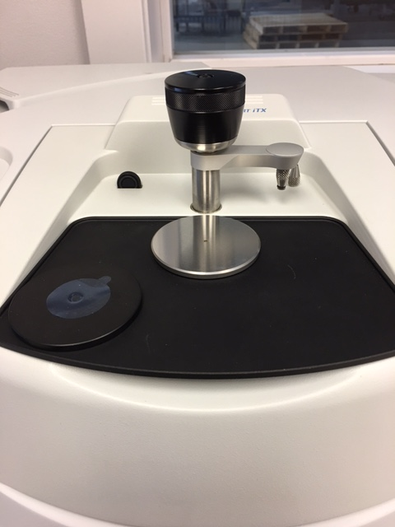

*Figure 4: Viewing area clear from objects.*

* + - 1. Take a Background Sample. Do not touch the table that the FTIR is on as to not disturb the reading *(Fig 5). NOTE: a background sampling should be taken every hour.*

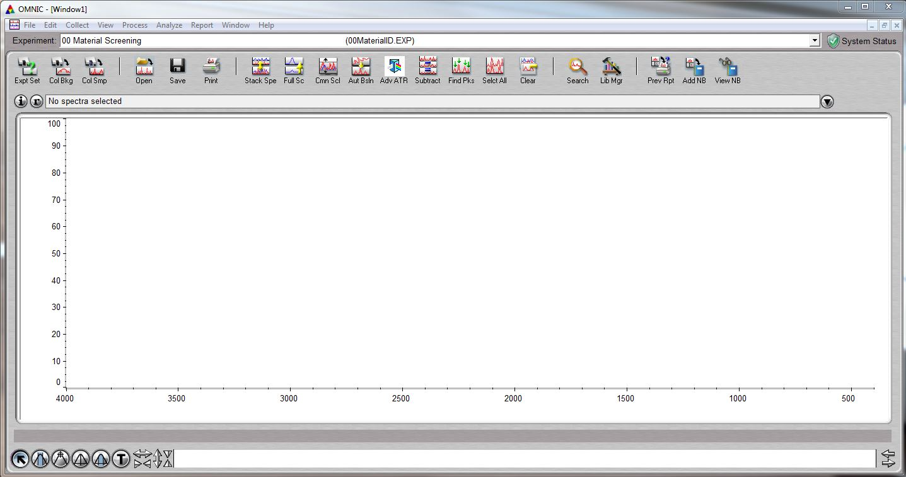

*Figure 5: Collect the Background Sample*

* + - 1. Do not add the Background Sample to Window1 *(Fig 6)*.

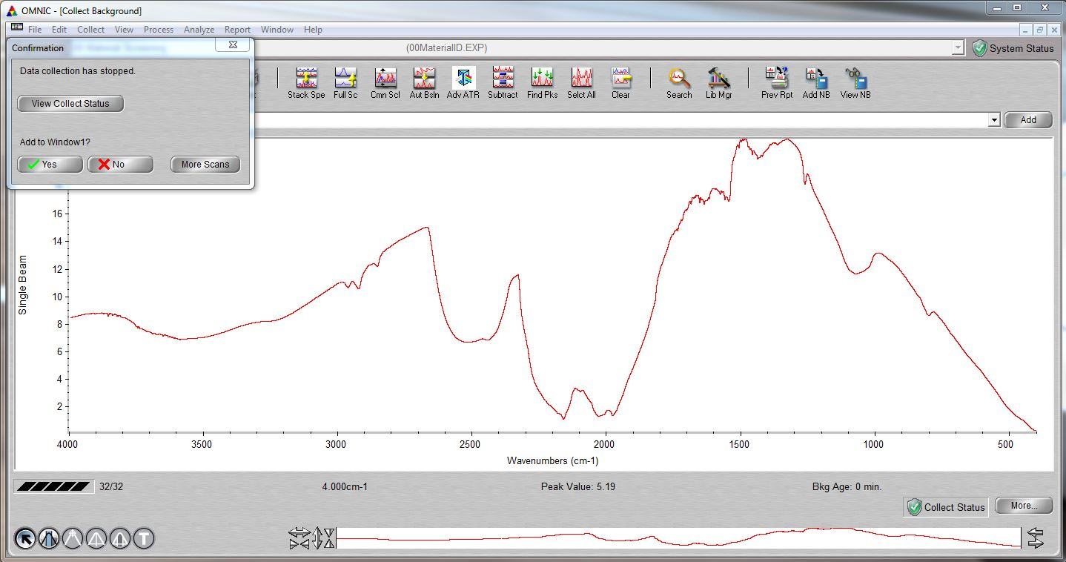

*Figure 6: Select “No” when prompted to add to Window1.*

1. General Test Procedure
   1. Lead Screening in Metals
      1. Remove any paint or coating from the metal. Bare, clean metal should be exposed to the XRF Guns eye, free of any debris.
      2. Click the “Sample Type” icon
      3. Click the “Metals” icon.
      4. Click the “Electronic Metals” icon.
      5. Press the data entry button and fill in the relevant information:
      6. Open the enclosure lid and place the bare metal over the eye of the gun.
      7. Close and lock the enclosure.
      8. Press the “Start” button.
      9. Allow it to run for a minimum of 30 seconds. The program will automatically stop after 1 minute.
      10. Once 30 seconds has been reached, press the “Stop” button.
      11. Remove the product from the enclosure and power down the system.
   2. Lead Screening in Plastics
      1. Click the “Sample Type” icon
      2. Click the “Consumer Goods” icon
      3. Click the “Plastics” icon*.*
      4. Press the data entry button and fill in the relevant information.
      5. Open the enclosure lid and place the plastic over the eye of the gun*.*
      6. Close and lock the enclosure.
      7. Press the “Start” button.
      8. Allow it to run for a minimum of 30 seconds. The program will automatically stop after 1 minute.
      9. Once 30 seconds has been reached, press the “Stop” button.
      10. Remove the product from the enclosure and power down the system.
   3. Toxics in Packaging Screening
      1. From home screen click the “Advanced Settings” icon

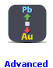

* + 1. Click the “Display Units” icon

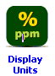

* + 1. On the plastics line change from % to PPM *(Fig 7).*

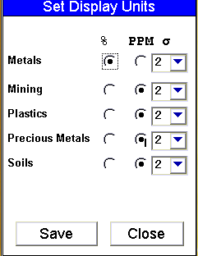

*Figure 7: Setting display units*

* + 1. Select Save
    2. Click the “Return” icon
    3. Click the “Sample Type” icon

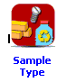

* + 1. Click the “Consumer Goods” icon



* + 1. Click the “Plastics” icon*.*



* + 1. Press the data entry button and fill in the relevant information.
    2. Open the enclosure lid and place the plastic over the eye of the gun*.*
    3. Close and lock the enclosure.
    4. Press the “Start” button.
    5. Allow it to run for a minimum of 30 seconds. The program will automatically stop after 1 minute.
    6. Once 30 seconds has been reached, press the “Stop” button.
    7. Remove the product from the enclosure and power down the system.
  1. Phthalate Screening
     1. Place the sample piece over the diamond *(Fig 8)*.

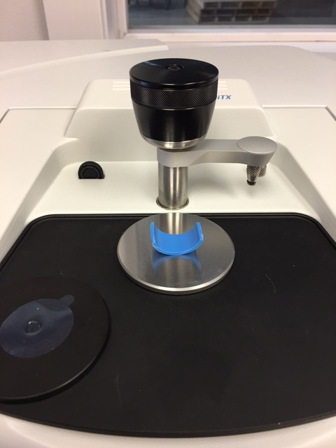

*Figure 8: Sample over the diamond.*

* + 1. Clamp the sample down until the clutch slips *(Fig 9)*.

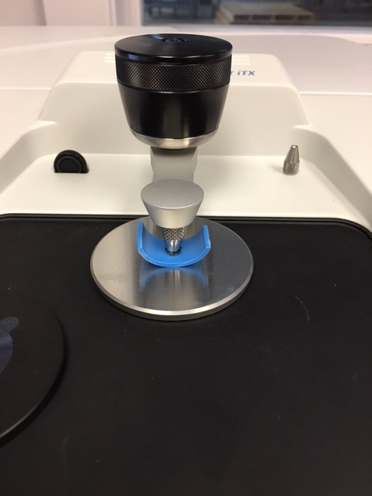

*Figure 9: Sample Clamped*

* + 1. Click “Collect Sample” *(Fig 10)*.



*Figure 10: Collect Sample icon circled.*

* + 1. A pop-up window will prompt you to enter a spectrum title. Put lot info, part number, and a description for the “Spectrum Title”.
    2. After the sample collection finishes, you will be prompted to add the collection to Window1. Select “Yes” *(Fig 11).*

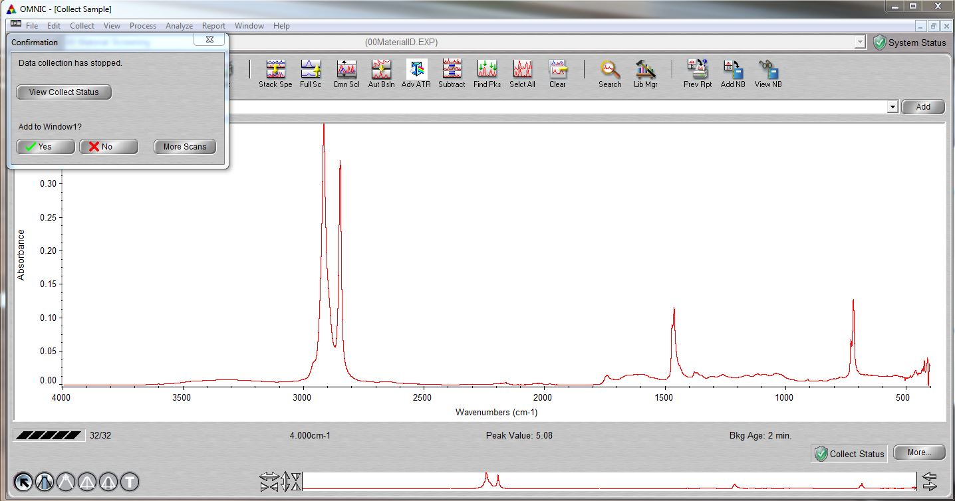

*Figure 11: Add collection to the window.*

* + 1. Click the “Lib Mgr” button *(Fig 12)*.

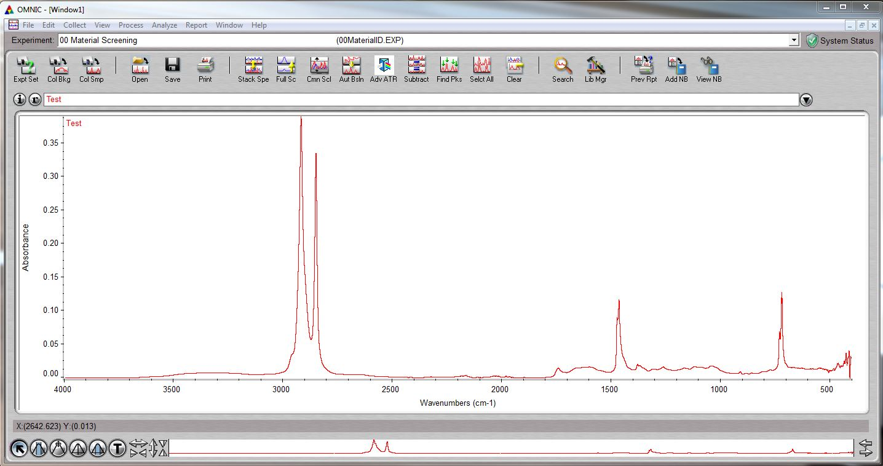

*Figure 12: Select the “Lib Mgr” Button*

* + 1. Navigate to Library Manager>Search Library>Phthalate>0.1% DEHP>Add to Window1 *(Fig 13)*.

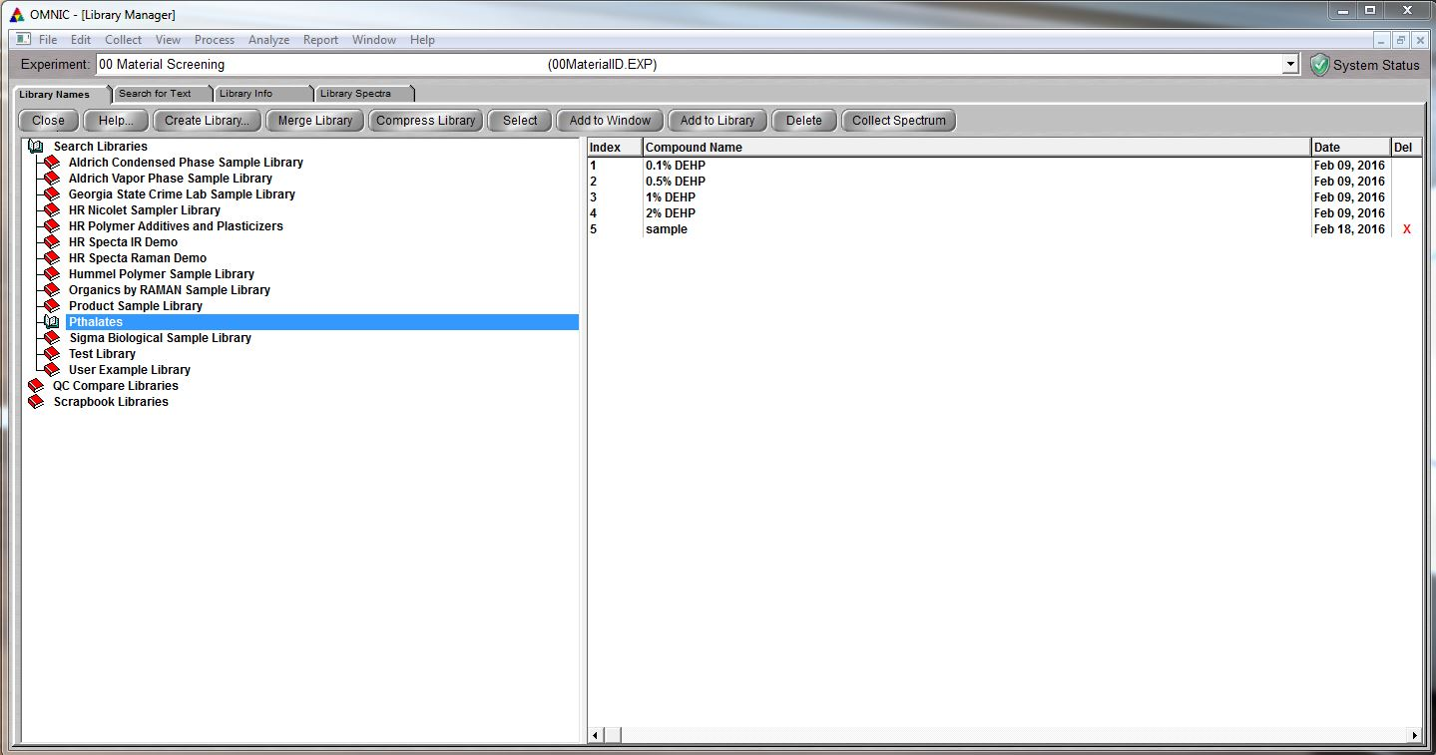

*Figure 13: Navigating to 0.1 DEHP*

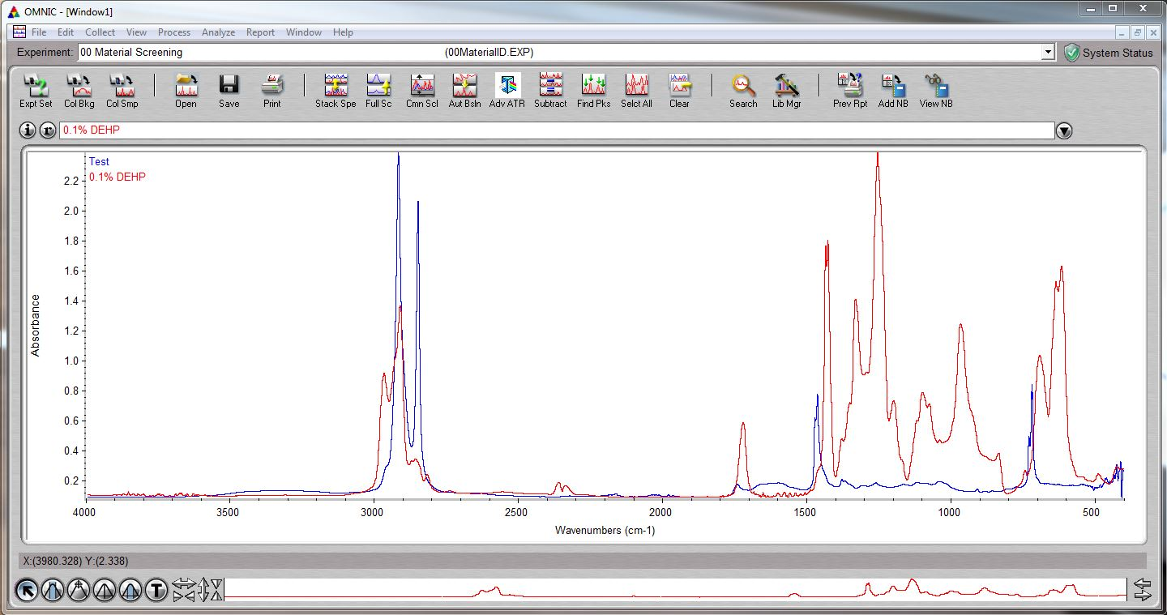

*Figure 14: Window1 once 0.1% DEHP line is added.*

* + 1. Zoom into 1580-1600 in wavenumbers window by clicking and dragging a box over those wavenumber span.
    2. Look for a double peak. If two peaks are identified in your sample’s wavelength, proceed to step 4.4.10. If there aren’t two distinct peaks on your sample’s wavelength, there is no phthalate presence and you can proceed to the reporting section *(Fig 15)*.

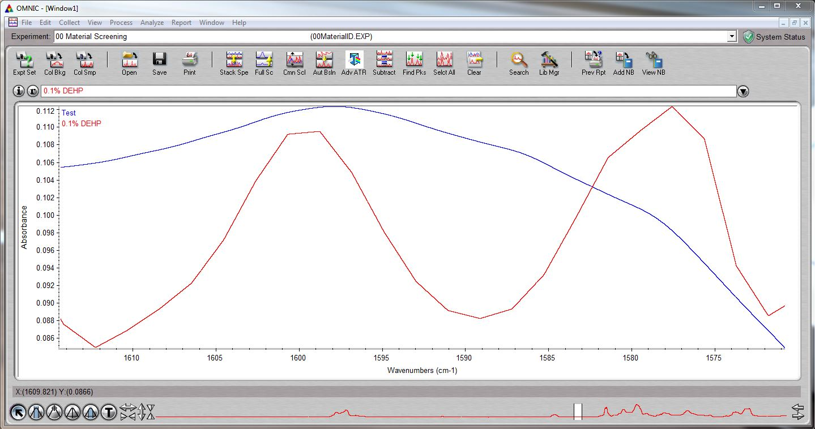

*Figure 15: Example reading with no phthalate presence.*

* + 1. To check regulatory satisfaction, click View>Common Scale or click on the “Cmn Scl” button and compare peaks *(Fig 16)*. Align both lines so that you can compare wave length heights *(Fig 17)*. If our samples absorbance level within the phthalate zone is higher than the 0.1% DEHP line, your sample has failed from phthalates. If there are peaks, but they are not higher, phthalates are detected, but they are at an acceptable level.

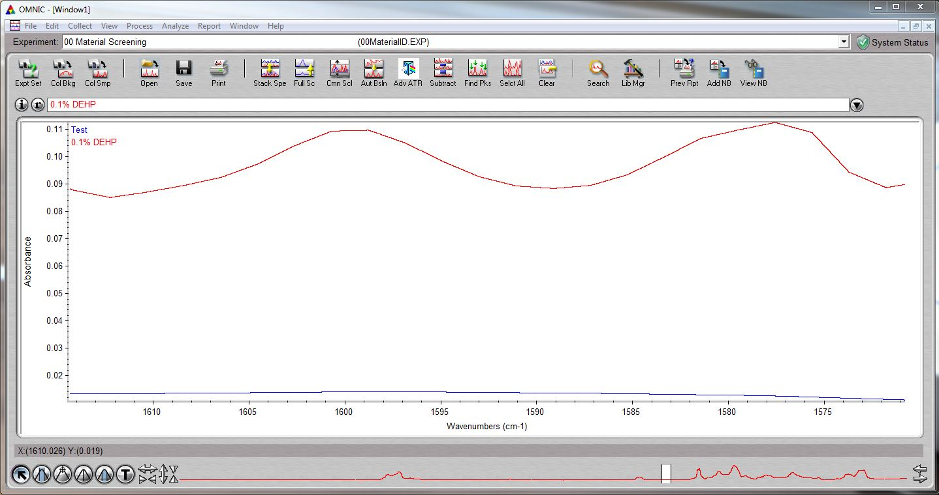

*Figure 16: Common Scale Selected*

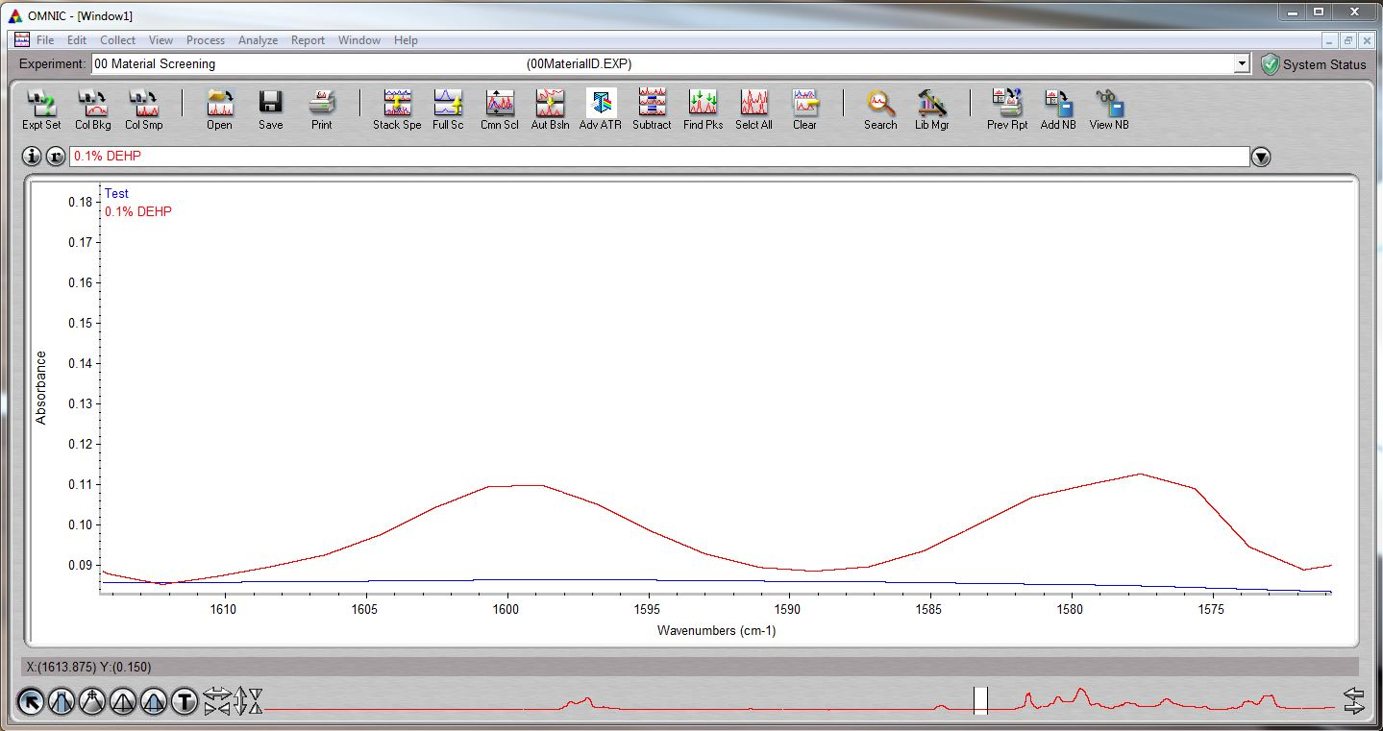

*Figure 17: Aligned Lines*

* + 1. If the sample failed, send an email to Joan Carter and Jonathan Ash.
    2. Take an alcohol pad and clean after every use. You can reuse the pad as long as no phthalates are detected.
    3. Once you have completely finished, wipe the plate and diamond with an alcohol pad and replace the cover over the plate and clamp down.

1. Data Format and Reporting
   1. Section 4.4
      1. Data logged here: J:/>Shared>1000 QE>Raw Test Data>Material Composition Log.
      2. Raw test data can be found in C:/omnic/autosave.

* END *